# Lab practice test

Question 1:

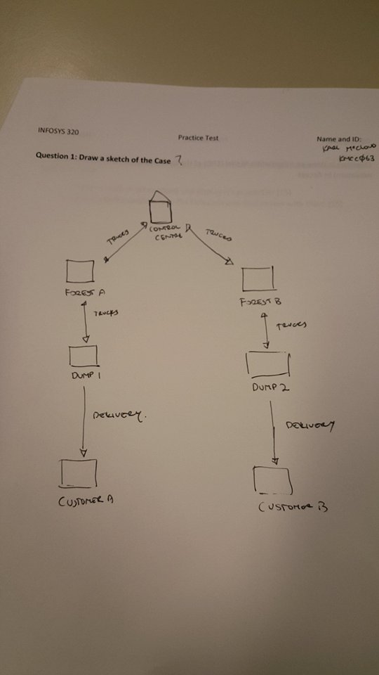

Question 2:

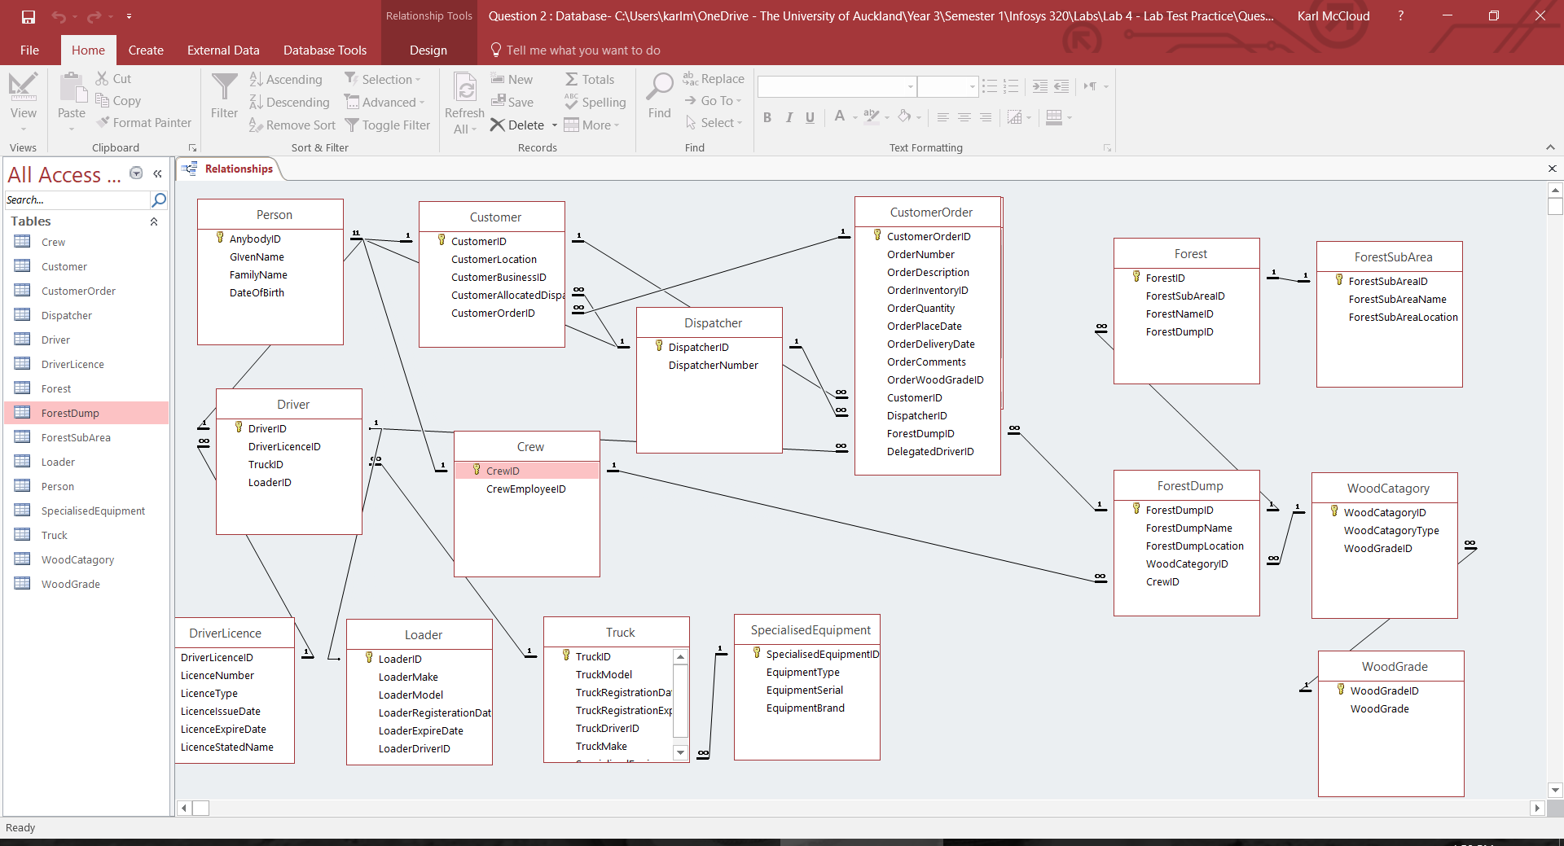

Question 3:

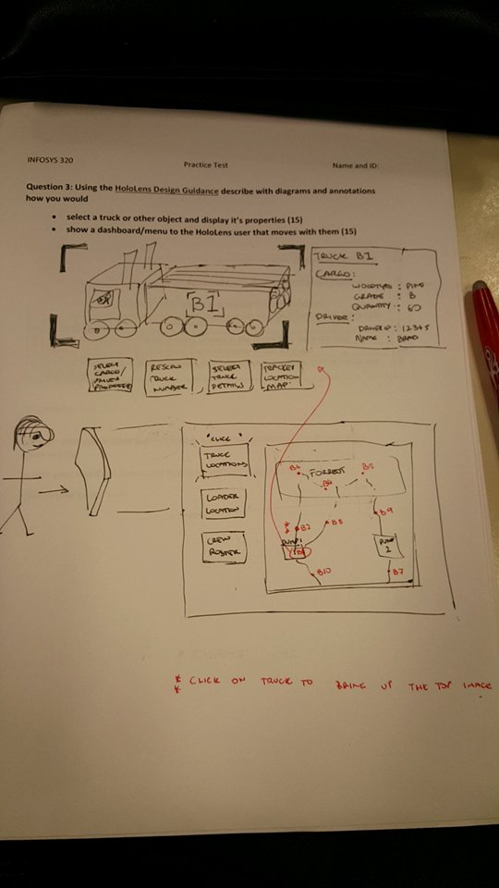

Question 4:

newCube.GetComponent<Renderer>().material.color = Color.blue;

Question 5: